CS 008 Introduction to World Wide Web Design

Benjamin Citrin

Assignment: The World in Pictures (2.0)

The World in Pictures

Version <1.0>

Table Of Contents

Time Log 3

Introduction 5

Purpose 5

Definitions, acronyms, and abbreviations 5

Overall Description 5

Story Board 6

Assignment requirements 7

Specific requirements 8

|  |  |  |  |
| --- | --- | --- | --- |
| Time Log | | | |
| Estimated time to complete assignment => | | | 17 Hours |
| Date | Time Spent  (in hours) | Description | Author |
| 2/12/15 | 1 | Looked over project requirements and reviewed php | Benjamin Citrin |
| 2/23/15 | 2 | Made all necessary php files based off of Bob’s templates | Benjamin Citrin |
| 2/25/15 | 4 | Made all pages, changed around some CSS and the layout, wrote out descriptions, made a gif | Benjamin Citrin |
| 2/28/15 | 2 | Added more images, edited php documents (nav, top, header, and footer) | Benjamin Citrin |
| 3/1/15 | 1 | Added email link at bottom, changed color scheme and list position | Benjamin Citrin |
| 3/2/15 | 3 | Played around with data.php; almost done with array, it just needs to be in table element | Benjamin Citrin |
| 3/3/15 | 1 | Made image map and transparent image | Benjamin Citrin |
| 3/4/15 | 1 | Reviewed requirements, check validations, asked questions on website | Benjamin Citrin |
| 3/5/15 | 1 | Reviewed footer.php, header.php, top.php, and nav.php for validation; redid php array with table element | Benjamin Citrin |
| 3/5/15 | 1 | Reviewed all requirements; submitted assignment | Benjamin Citrin |
|  |  |  |  |
|  |  |  |  |
|  |  |  |  |
|  |  |  |  |
|  |  |  |  |
|  |  |  |  |
|  |  |  |  |
|  |  |  |  |
|  | 17 Hours | <=Total Time Spent |  |

# Introduction

### Purpose

The purpose of this document is to describe the requirement specification for the web site “The World in Pictures”.

The intended audience for this document is two fold. First it is the contract between you and the client and the developer of the site. Two primary goals are:

1. Client gets a very good understanding of what you will be delivering.
2. Developer has a very good understanding of what they are going to create.

The web site to be created is all about images and data. You will need at least four pages.

### Definitions, acronyms, and abbreviations

HTML – Hypertext markup language – used to define your content.

PHP – Personal Home Page – language that helps to customize html.

CSS – Cascading Style Sheets – used to define the look of a web site.

W3 Validation – refers to both Html and CSS validation tool provided by the W3c.org. the html validator is located at:

<http://validator.w3.org/>

with the CSS validator located at:

<http://jigsaw.w3.org/css-validator/>

# Overall Description

The theme for my images is snow. With that said, I really enjoy skiing and snowboarding, so those are going to be my primary shots. Secondary photos will include pictures involving the snow around campus and in Burlington.

# Story Board

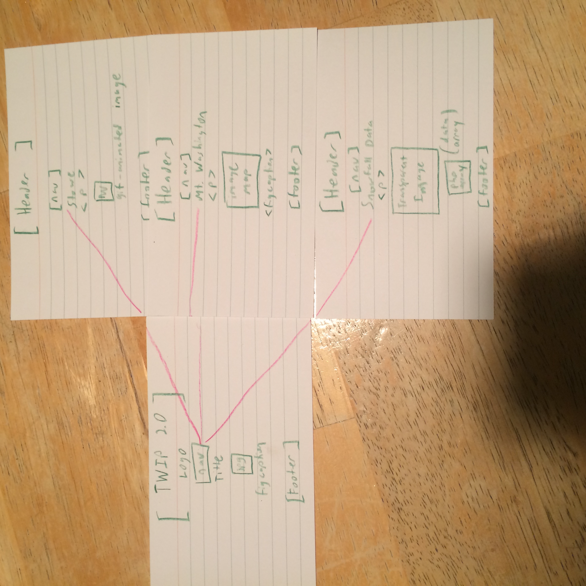

# Assignment requirements

1. *Location* – all files will be located in the www-root/cs008 folder.
2. *Html Validation* – All pages will pass W3C Html validation for html 5.
3. *Meta Information* – All pages will contain a proper title tag, Meta tags (author, character set and description).
4. CSS Validation – All pages will pass W3C 3.0 CSS validation.
5. CSS – all pages will have a linked style sheet. (you are graded on effort).
6. *Head Section* – put the doctype and head section information in a file named top.php so you can include it all the pages.
7. *Navigation* – All pages will contain navigation to all other pages on the site using an ordered list (4 pages minimum). File name should be nav.php which you will include on all pages.
8. *Content* – Each page will have a minimum of 100 words not counting titles, lists or links. Be sure to use the correct elements to hold your content.
9. *Header* – All pages will contain a header with the logo about your site. File name should be header.php which you will include on all pages.
10. *Footer* – All pages will contain a footer with the content determined by you. Filename will be footer.php which you will include on all pages.
11. *CSV File* – Create a csv file with data related to your site, It can be image meta data or informational data. You must have at least nine rows of data. Add the code to Open, Read, Close and Display this data in a **table element**. Name the page to display the data: data.php
12. *Images* – Each page will have a minimum of one image. All images should be in a figure element.
13. *Types of images* – Create each of these images on your site. Each image will be in the figure element with the figcaption element identifying the type of image as listed below (easier for the grader)
    1. *Animated image*
    2. *Transparent image*
    3. *Image map with a minimum of three links (these can be external)*
14. *Browser compatibility* - This site will be checked on Firefox, Safari, Chrome and Internet Explorer.
15. *Footer* – All pages will contain a footer with your name. Be sure to use the correct element to contain the footer.
16. *File Names* – the main home page will be called index.php with the rest of the file names up to you (be sure to use .php).
17. *Specification Document (this file)*: must be updated and saved as a specs.pdf (must use pdf format and correct filename in the same folder to be graded).

# Specific requirements

1. *Location –* all files accessible from sitemap.php
2. *Validation –* all pages validated with W3C html5
3. *Meta Information –* all pages contain a proper title tag, and other meta tags
4. *CSS Validation –* all pages pass W3C 3.0 CSS validation
5. *CSS Stylesheet –* all pages are linked to a stylesheet
6. Top.php is included on all pages with proper doctype
7. *Navigation –* four pages included; all link to one another
8. *Content –* each pages contains over 100 words and use proper tags
9. *Header –* all pages have a header, which contains my site logo, header.php
10. *Footer –* all pages have a footer with my name and email, footer.php
11. *CSV file –* data read through php in the data.php section; data is on snowfall; data is displayed in a table element
12. *Images –* each page has an image in a figure element
13. There is an animated image, a transparent image, and an image map with three links. They each are in a figure element with a figcaption
14. *Browser compatibility* - This site is compatible with Firefox, Safari, Chrome and Internet Explorer
15. File names – main home page is index.php
16. Spec doc is uploaded in pdf format